Supplemental materials
Alliance complements or substitutes? Explaining bilateral intergovernmental strategic partnership ties

Table of contents
Appendix 1 – Cross-tabulations 2
Appendix 2 – Logit models with dyad clustered standard errors 4
Appendix 3 – Probit models with dyad clustered standard errors 8
Appendix 4 – Logit models with dyadic cluster-robust standard errors 10
Appendix 5 – Probit models with dyadic cluster-robust standard errors 13
Appendix 6 – Multicollinearity diagnostics 15
Appendix 7 – Higher order interactions 18
Appendix 8 – Alternative operationalization of polity difference 23
Appendix 9 – Examples of BISPs as “stepping stones” for formal alliances 27
References 29

Appendix 1 – Cross-tabulations
Below, I present cross-tabulations for Figure 3 and 4 (bar charts) in the main text. Table 1 and 2 correspond to Figure 3, while Table 3 and 4 correspond to Figure 4.
Table 1. Cross-tabulations of BISP ties across common threat
Common threat | BISP tie
 | 0 | 1 | Total
0 (No common threat) | 2890 (2831.4) | 176 (234.6) | 3066
 | 94.26 | 5.74 | 100.00
1 (Common threat) | 356 (414.6) | 93 (34.4) | 449
 | 79.29 | 20.71 | 100.00
Total | 3246 | 269 | 3515
 | 92.35 | 7.65 | 100.00
Pearson Chi2 = 124.23 Prob = 0.0000
First row has observed frequencies and expected frequencies in parentheses, second row has row percentages

Table 2. Cross-tabulations of BISP ties across alliance
Alliance | BISP tie
 | 0 | 1 | Total
0 (No formal alliance) | 2461 (2377.0) | 113 (197.0) | 2574
 | 95.61 | 4.39 | 100.00
1 (Formal alliance) | 785 (869.0) | 156 (72.0) | 941
 | 83.42 | 16.58 | 100.00
Total | 3246 | 269 | 3515
 | 92.35 | 7.65 | 100.00
Pearson Chi2 = 144.84 Prob = 0.0000
First row has observed frequencies and expected frequencies in parentheses, second row has row percentages

Table 3: Cross-tabulations of BISP ties across alliance, common threat subset
Alliance | BISP tie
 | 0 | 1 | Total
0 (No formal alliance) | 125 (123.7) | 31 (32.3) | 156
 | 80.13 | 19.87 | 100.00
1 (Formal alliance) | 231 (232.3) | 62 (60.7) | 293
 | 78.84 | 21.16 | 100.00
Total | 356 | 93 | 449
 | 79.29 | 20.71 | 100.00
Pearson Chi2 = 0.10 Prob = 0.7483
First row has observed frequencies and expected frequencies in parentheses, second row has row percentages

Table 4. Cross-tabulations of BISP ties across alliance commitments, common threat subset
Alliance commitment | BISP tie
 | 0 | 1 | Total
0 (No commitment) | 125 (123.7) | 31 (32.3) | 156
 | 80.13 | 19.87 | 100.00
1 (Low commitment) | 63 (82.5) | 41 (21.5) | 104
 | 60.58 | 39.42 | 100.00
2 (High commitment) | 168 (149.9) | 21 (39.1) | 189
 | 88.89 | 11.11 | 100.00
Total | 356 | 93 | 449
 | 79.29 | 20.71 | 100.00
Pearson Chi2 = 32.85 Prob = 0.0000
First row has observed frequencies and expected frequencies in parentheses, second row has row percentages

Appendix 2 – Logit models with dyad clustered standard errors
Table 1 below summarizes the results of the logistic regression corresponding to Figure 5 (coefficient plot) in the main text. Note that standard errors are clustered on dyad. Table 2 below then provides the predictive margins for Figure 6 (interaction plot) in the main text. Table 3 summarizes the results of the logistic regression corresponding to Figure 7 (coefficient plot) in the main text. Table 4 then provides the predictive margins for Figure 8 (interaction plot) in the main text. Finally Figures 1 and 2 below depict receiver operating characteristic (ROC) curves for models 1 through 8. These figures suggest that models with controls perform much better at distinguishing between classes – whether there is or is not a BISP tie – than models without controls. Additionally, models with the interaction term perform slightly better than models without the interaction term. This is also reflected in higher McFadden Pseudo R² scores for the respective models.
Table 1. Logistic regression of BISP ties
 | Model 1 | Model 2 | Model 3 | Model 4
Common threat | 0.961*** | 0.459* | 0.103 | -0.427
 | (0.168) | (0.181) | (0.195) | (0.232)
No formal alliance | -1.187*** | -1.576*** | -0.560** | -0.934***
 | (0.152) | (0.158) | (0.186) | (0.196)
Common threat * No formal alliance |  | 1.497*** |  | 1.457***
 |  | (0.293) |  | (0.348)
Trade value (log) |  |  | 1.160*** | 1.164***
 |  |  | (0.0956) | (0.0973)
Polity difference |  |  | 0.0173 | 0.0129
 |  |  | (0.0125) | (0.0127)
Foreign policy difference |  |  | -0.0229 | -0.0535
 |  |  | (0.0783) | (0.0799)
Power differential |  |  | 3.873*** | 3.795***
 |  |  | (0.984) | (1.001)
Conflict relations |  |  | -1.467** | -1.467**
 |  |  | (0.486) | (0.453)
Constant | -1.982*** | -1.774*** | -5.786*** | -5.519***
 | (0.125) | (0.112) | (0.368) | (0.371)
N | 3515 | 3515 | 2808 | 2808
McFadden Pseudo R² | 0.087 | 0.099 | 0.240 | 0.251
Note: Dyad clustered standard errors in parentheses; * p < 0.05, ** p < 0.01, *** p < 0.001

Table 2. Predictive margins of Common threat * Alliance
 | Margin | Std. err. | z | P > z | 95% conf. interval
No common threat, No formal alliance | 0.051 | 0.005 | 9.410 | 0.000 | 0.040 | 0.062
No common threat, Formal alliance | 0.107 | 0.011 | 9.580 | 0.000 | 0.085 | 0.129
Common threat, No formal alliance | 0.261 | 0.038 | 6.800 | 0.000 | 0.186 | 0.336
Common threat, Formal alliance | 0.186 | 0.023 | 8.170 | 0.000 | 0.142 | 0.231

Table 3. Logistic regression of BISP ties
 | Model 5 | Model 6 | Model 7 | Model 8
Common threat | 1.249*** | -0.198 | 0.401 | -1.226**
 | (0.183) | (0.322) | (0.208) | (0.401)
No commitment | -0.436 | -1.468*** | 0.409 | -0.651*
 | (0.246) | (0.250) | (0.313) | (0.313)
Low commitment | 1.054*** | 0.146 | 1.320*** | 0.296
 | (0.233) | (0.258) | (0.290) | (0.316)
Common threat * No commitment |  | 2.153*** |  | 2.261***
 |  | (0.396) |  | (0.476)
Common threat * Low commitment |  | 1.504*** |  | 1.902***
 |  | (0.401) |  | (0.489)
Trade value (log) |  |  | 1.230*** | 1.259***
 |  |  | (0.0977) | (0.102)
Polity difference |  |  | -0.000444 | -0.00358
 |  |  | (0.0136) | (0.0137)
Foreign policy difference |  |  | -0.0530 | -0.0978
 |  |  | (0.0820) | (0.0826)
Power differential |  |  | 3.395*** | 3.065**
 |  |  | (1.008) | (1.047)
Conflict relations |  |  | -1.838*** | -1.960***
 |  |  | (0.530) | (0.538)
Constant | -2.774*** | -1.882*** | -6.812*** | -5.872***
 | (0.241) | (0.224) | (0.482) | (0.468)
N | 3515 | 3515 | 2808 | 2808
McFadden Pseudo R² | 0.101 | 0.116 | 0.258 | 0.274
Note: Dyad clustered standard errors in parentheses; * p < 0.05, ** p < 0.01, *** p < 0.001

Table 4. Predictive margins of Common threat * Alliance commitment
 | Margin | Std. err. | z | P > z | 95% conf. interval
No common threat, No commitment | 0.052 | 0.005 | 9.600 | 0.000 | 0.042 | 0.063
No common threat, Low commitment | 0.109 | 0.013 | 8.490 | 0.000 | 0.084 | 0.135
No common threat, High commitment | 0.088 | 0.019 | 4.710 | 0.000 | 0.051 | 0.124
Common threat, No commitment | 0.278 | 0.039 | 7.140 | 0.000 | 0.201 | 0.354
Common threat, Low commitment | 0.378 | 0.043 | 8.750 | 0.000 | 0.293 | 0.463
Common threat, High commitment | 0.091 | 0.021 | 4.240 | 0.000 | 0.049 | 0.133

Figure 1. ROC curves for models 1–4
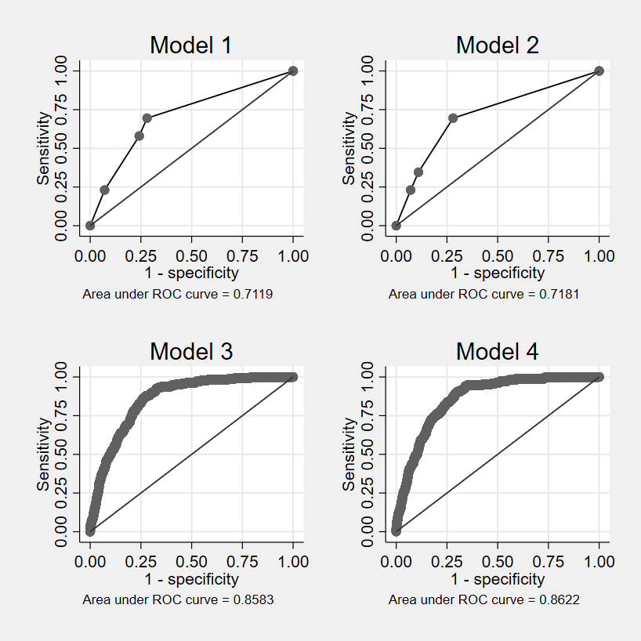
Note: Graphs above depict the predictive ability of the four models. The Y axis (“Sensitivity”) represents true positive rate, while the X axis (“1 – specificity”) represents false positive rate. The closer the line gets to the top left corner (and the farther it moves from the diagonal line), the closer the model to perfect classification. The area under the curve (AUC) statistic measures the ability of the model to distinguish between classes.

Figure 2. ROC curves for models 5–8
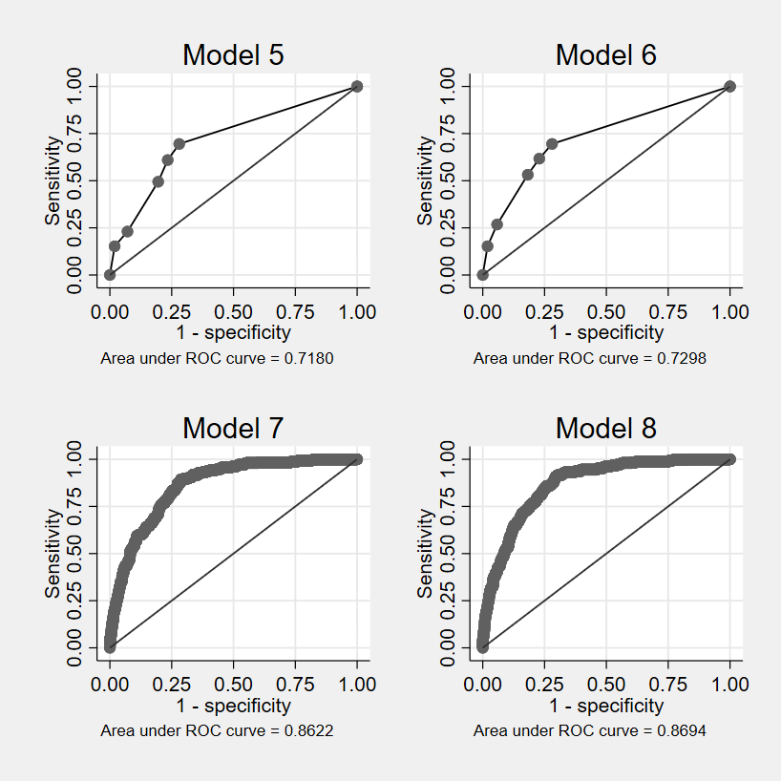
Note: Graphs above depict the predictive ability of the four models. The Y axis (“Sensitivity”) represents true positive rate, while the X axis (“1 – specificity”) represents false positive rate. The closer the line gets to the top left corner (and the farther it moves from the diagonal line), the closer the model to perfect classification. The area under the curve (AUC) statistic measures the ability of the model to distinguish between classes.

Appendix 3 – Probit models with dyad clustered standard errors
As a robustness check, I ran models 1–8 using probit regression with dyad clustered standard errors (see Table 1 and 2). There are no notable changes in Table 1. Additionally, the only notable changes in Table 2 relate to No commitment, which becomes statistically significant (at p < 0.05 level) in Model 5, and Common threat, which becomes statistically significant (at p < 0.05 level) in Model 7. The former result provides some limited evidence in support of H2b. Otherwise, the results remain robust.
Table 1. Probit regression of BISP ties
 | Model 1 | Model 2 | Model 3 | Model 4
Common threat | 0.535*** | 0.257* | 0.0849 | -0.212
 | (0.0866) | (0.102) | (0.101) | (0.124)
No formal alliance | -0.605*** | -0.768*** | -0.329*** | -0.519***
 | (0.0728) | (0.0779) | (0.0938) | (0.0998)
Common threat * No formal alliance |  | 0.723*** |  | 0.768***
 |  | (0.161) |  | (0.186)
Trade value (log) |  |  | 0.612*** | 0.617***
 |  |  | (0.0508) | (0.0514)
Polity difference |  |  | 0.0101 | 0.00783
 |  |  | (0.00655) | (0.00667)
Foreign policy difference |  |  | -0.0158 | -0.0270
 |  |  | (0.0416) | (0.0425)
Power differential |  |  | 2.157*** | 2.116***
 |  |  | (0.549) | (0.555)
Conflict relations |  |  | -0.796*** | -0.795***
 |  |  | (0.241) | (0.237)
Constant | -1.159*** | -1.058*** | -3.132*** | -3.004***
 | (0.0621) | (0.0607) | (0.191) | (0.192)
N | 3515 | 3515 | 2808 | 2808
McFadden Pseudo R² | 0.089 | 0.099 | 0.247 | 0.257
Note: Dyad clustered standard errors in parentheses; * p < 0.05, ** p < 0.01, *** p < 0.001

Table 2. Probit regression of BISP ties
 | Model 5 | Model 6 | Model 7 | Model 8
Common threat | 0.653*** | -0.105 | 0.215* | -0.613**
 | (0.0932) | (0.170) | (0.107) | (0.205)
No commitment | -0.241* | -0.710*** | 0.128 | -0.393*
 | (0.119) | (0.130) | (0.150) | (0.162)
Low commitment | 0.529*** | 0.0788 | 0.655*** | 0.144
 | (0.120) | (0.139) | (0.146) | (0.169)
Common threat * No commitment |  | 1.084*** |  | 1.175***
 |  | (0.211) |  | (0.248)
Common threat * Low commitment |  | 0.874*** |  | 1.014***
 |  | (0.222) |  | (0.261)
Trade value (log) |  |  | 0.643*** | 0.655***
 |  |  | (0.0521) | (0.0539)
Polity difference |  |  | 0.00270 | 0.000754
 |  |  | (0.00693) | (0.00705)
Foreign policy difference |  |  | -0.0387 | -0.0530
 |  |  | (0.0428) | (0.0435)
Power differential |  |  | 1.880*** | 1.734**
 |  |  | (0.554) | (0.569)
Conflict relations |  |  | -0.960*** | -1.041***
 |  |  | (0.260) | (0.261)
Constant | -1.538*** | -1.116*** | -3.601*** | -3.137***
 | (0.117) | (0.120) | (0.238) | (0.240)
N | 3515 | 3515 | 2808 | 2808
McFadden Pseudo R² | 0.102 | 0.116 | 0.262 | 0.278
Note: Dyad clustered standard errors in parentheses; * p < 0.05, ** p < 0.01, *** p < 0.001

Appendix 4 – Logit models with dyadic cluster-robust standard errors
As an additional robustness check, I repeated the analysis using dyadic cluster-robust standard errors (DCRSEs). The goal of this additional analysis was to ensure that the findings reported in the main text are robust to the use of comprehensive corrections for “dyadic clustering,” which can occur in dyadic data because observations are not independent across units. In other words, dyads that share a common member are likely correlated with one another, thus violating the independent observations assumption of the logistic regression. Due to the complex dependency structure of dyadic data, model errors can be correlated across dyads, leading to overconfidence in tests of statistical significance (see Aronow et al., 2015; Carlson et al., 2021; Erikson et al., 2014). The usual approach when working with dyadic data with a binary dependent variable is to regress the dyad-level outcome on unit- and dyad-level predictors (Aronow et al., 2015, p. 565). I followed the same procedure to obtain the results reported in the main text. Yet, this approach still fails to account for “dyadic clustering” because it assumes that all dyads that do not share both members are independent. This is potentially problematic since the dataset I use contains dyads, where at least one of the members is always a G20 country. Comprehensive corrections for “dyadic clustering,” such as DCRSEs, partially address this issue by accounting for interdependencies between dyads that share a common member. I used the recently released DCR package for Stata (Carlson et al., 2021) and ran models 1–4 with DCRSEs. The results in Table 1 and 2 below show that the findings remain robust to the alternative method of estimation. The only notable change relates to Common threat, which loses statistical significance in Model 2 and 8, and No commitment, which loses statistical significance in Model 8.

Table 1. Logistic regression of BISP ties
 | Model 1 | Model 2 | Model 3 | Model 4
Common threat | 0.961*** | 0.459 | 0.103 | -0.427
 | (0.216) | (0.242) | (0.337) | (0.393)
No formal alliance | -1.187*** | -1.576*** | -0.560* | -0.934***
 | (0.248) | (0.223) | (0.248) | (0.197)
Common threat * No formal alliance |  | 1.497*** |  | 1.457***
 |  | (0.347) |  | (0.334)
Trade value (log) |  |  | 1.160*** | 1.164***
 |  |  | (0.164) | (0.171)
Polity difference |  |  | 0.0173 | 0.0129
 |  |  | (0.0191) | (0.0192)
Foreign policy difference |  |  | -0.0229 | -0.0535
 |  |  | (0.0940) | (0.0873)
Power differential |  |  | 3.873*** | 3.795***
 |  |  | (1.133) | (1.0447)
Conflict relations |  |  | -1.467** | -1.467**
 |  |  | (0.568) | (0.515)
Constant | -1.982*** | -1.774*** | -5.786*** | -5.519***
 | (0.249) | (0.226) | (0.423) | (0.416)
N | 3515 | 3515 | 2808 | 2808
McFadden Pseudo R² | 0.087 | 0.099 | 0.240 | 0.251
Note: Dyadic cluster-robust standard errors in parentheses; * p < 0.05, ** p < 0.01, *** p < 0.001

Table 2. Logistic regression of BISP ties (DCRSEs)
 | Model 5 | Model 6 | Model 7 | Model 8
Common threat | 1.249*** | -0.198 | 0.401 | -1.226
 | (0.220) | (0.441) | (0.329) | (0.642)
No commitment | -0.436 | -1.468*** | 0.409 | -0.651
 | (0.423) | (0.341) | (0.435) | (0.431)
Low commitment | 1.054** | 0.146 | 1.320** | 0.296
 | (0.409) | (0.452) | (0.457) | (0.516)
Common threat * No commitment |  | 2.153*** |  | 2.261***
 |  | (0.495) |  | (0.638)
Common threat * Low commitment |  | 1.504** |  | 1.902**
 |  | (0.475) |  | (0.581)
Trade value (log) |  |  | 1.230*** | 1.259***
 |  |  | (0.156) | (0.163)
Polity difference |  |  | -0.000444 | -0.00358
 |  |  | (0.0176) | (0.0179)
Foreign policy difference |  |  | -0.0530 | -0.0978
 |  |  | (0.0996) | (0.0926)
Power differential |  |  | 3.395*** | 3.065**
 |  |  | (1.026) | (0.943)
Conflict relations |  |  | -1.838** | -1.960***
 |  |  | (0.599) | (0.592)
Constant | -2.774*** | -1.882*** | -6.812*** | -5.872***
 | (0.392) | (0.303) | (0.651) | (0.634)
N | 3515 | 3515 | 2808 | 2808
McFadden Pseudo R² | 0.101 | 0.116 | 0.258 | 0.274
Note: Dyadic cluster-robust standard errors in parentheses; * p < 0.05, ** p < 0.01, *** p < 0.001

Appendix 5 – Probit models with dyadic cluster-robust standard errors
Lastly, I repeated the analysis using the probit regression method with DCRSEs (see Table 1 and 2). Again, I compared these results with those reported in the main text. The only notable changes relate to Common threat, which loses statistical significance in Model 2 and 8, and No commitment, which loses statistical significance in Model 8. Otherwise, the results remain robust.
Table 1. Probit regression of BISP ties (DCRSEs)
 | Model 1 | Model 2 | Model 3 | Model 4
Common threat | 0.535*** | 0.257 | 0.0849 | -0.212
 | (0.113) | (0.138) | (0.171) | (0.204)
No formal alliance | -0.605*** | -0.768*** | -0.329** | -0.519***
 | (0.120) | (0.108) | (0.108) | (0.100)
Common threat * No formal alliance |  | 0.723*** |  | 0.768***
 |  | (0.193) |  | (0.174)
Trade value (log) |  |  | 0.612*** | 0.617***
 |  |  | (0.0853) | (0.0886)
Polity difference |  |  | 0.0101 | 0.00783
 |  |  | (0.00981) | (0.00991)
Foreign policy difference |  |  | -0.0158 | -0.0270
 |  |  | (0.0504) | (0.0480)
Power differential |  |  | 2.157*** | 2.116***
 |  |  | (0.604) | (0.572)
Conflict relations |  |  | -0.796** | -0.795**
 |  |  | (0.276) | (0.259)
Constant | -1.159*** | -1.058*** | -3.132*** | -3.004***
 | (0.129) | (0.123) | (0.209) | (0.202)
N | 3515 | 3515 | 2808 | 2808
McFadden Pseudo R² | 0.089 | 0.099 | 0.247 | 0.257
Note: Dyadic cluster-robust standard errors in parentheses; * p < 0.05, ** p < 0.01, *** p < 0.001

Table 2. Probit regression of BISP ties (DCRSEs)
 | Model 5 | Model 6 | Model 7 | Model 8
Common threat | 0.653*** | -0.105 | 0.215 | -0.613
 | (0.113) | (0.233) | (0.168) | (0.318)
No commitment | -0.241 | -0.710*** | 0.128 | -0.393
 | (0.208) | (0.171) | (0.212) | (0.223)
Low commitment | 0.529* | 0.0788 | 0.655** | 0.144
 | (0.223) | (0.245) | (0.232) | (0.273)
Common threat * No commitment |  | 1.084*** |  | 1.175***
 |  | (0.268) |  | (0.328)
Common threat * Low commitment |  | 0.874*** |  | 1.014***
 |  | (0.250) |  | (0.290)
Trade value (log) |  |  | 0.643*** | 0.655***
 |  |  | (0.0830) | (0.0852)
Polity difference |  |  | 0.00270 | 0.000754
 |  |  | (0.00944) | (0.00948)
Foreign policy difference |  |  | -0.0387 | -0.0530
 |  |  | (0.0515) | (0.0489)
Power differential |  |  | 1.880** | 1.734**
 |  |  | (0.594) | (0.555)
Conflict relations |  |  | -0.960*** | -1.041***
 |  |  | (0.288) | (0.286)
Constant | -1.538*** | -1.116*** | -3.601*** | -3.137***
 | (0.195) | (0.163) | (0.319) | (0.323)
N | 3515 | 3515 | 2808 | 2808
McFadden Pseudo R² | 0.102 | 0.116 | 0.262 | 0.278
Note: Dyadic cluster-robust standard errors in parentheses; * p < 0.05, ** p < 0.01, *** p < 0.001

Appendix 6 – Multicollinearity diagnostics
During the review process, one of the reviewers noted that, because the results of the analysis seem to be model dependent, it is necessary to check for potential multicollinearity issues by computing Variance Inflation Factor (VIF) scores. It bears noting that multiplicative interaction models typically produce high VIF scores due to the inclusion of the interaction term along with the constitutive terms. Higher VIF scores in this context do not justify the exclusion of the constitutive terms (Brambor et al., 2006, p. 70). Since the “vif” command in Stata is not allowed after “logit,” I used the “regres” command instead (i.e., OLS regression) to produce models 1–8 (see Table 2 and 4 on the following pages). Table 1 and 3 below suggest that VIF scores are within acceptable levels (i.e., < 5) for all independent variables across all models. On balance, interaction models attain slightly higher scores – particularly due to higher VIF values of the interaction terms (i.e., Common threat * No formal alliance, Common threat * No commitment, and Common threat * Low commitment) and the constitutive terms (i.e., Common threat, No formal alliance, No commitment, and Low commitment). Again, however, this is an artifact of the inclusion of the interaction term along with the constitutive terms.
Table 1. Variance inflation factor
 | Model 1 | Model 2 | Model 3 | Model 4
Common threat | 1.124 | 1.941 | 1.228 | 2.091
No formal alliance | 1.124 | 1.348 | 1.290 | 1.571
Common threat * No formal alliance |  | 1.756 |  | 1.821
Trade value (log) |  |  | 1.392 | 1.394
Polity difference |  |  | 1.085 | 1.091
Foreign policy difference |  |  | 1.048 | 1.050
Power differential |  |  | 1.138 | 1.138
Conflict relations |  |  | 1.039 | 1.039
Mean VIF | 1.124 | 1.682 | 1.174 | 1.399

Table 2. OLS regression of BISP ties
 | Model 1 | Model 2 | Model 3 | Model 4
Common threat | 0.108*** | 0.0665* | 0.0368 | -0.00900
 | (0.0210) | (0.0276) | (0.0221) | (0.0293)
No formal alliance | -0.0948*** | -0.111*** | -0.0595*** | -0.0804***
 | (0.0137) | (0.0143) | (0.0157) | (0.0166)
Common threat * No formal alliance |  | 0.0983* |  | 0.107*
 |  | (0.0424) |  | (0.0427)
Trade value (log) |  |  | 0.0618*** | 0.0612***
 |  |  | (0.00533) | (0.00529)
Polity difference |  |  | 0.00127 | 0.00105
 |  |  | (0.000839) | (0.000834)
Foreign policy difference |  |  | -0.00538 | -0.00644
 |  |  | (0.00580) | (0.00584)
Power differential |  |  | 0.623*** | 0.615***
 |  |  | (0.136) | (0.135)
Conflict relations |  |  | -0.110*** | -0.110***
 |  |  | (0.0332) | (0.0333)
Constant | 0.132*** | 0.145*** | -0.0430* | -0.0222
 | (0.0131) | (0.0138) | (0.0192) | (0.0198)
N | 3515 | 3515 | 2808 | 2808
R² | 0.058 | 0.061 | 0.140 | 0.144
Note: Dyad clustered standard errors in parentheses; * p < 0.05, ** p < 0.01, *** p < 0.001

Table 3. Variance inflation factor
 | Model 5 | Model 6 | Model 7 | Model 8
Common threat | 1.215 | 4.323 | 1.326 | 4.784
No commitment | 2.618 | 4.245 | 2.936 | 4.888
Low commitment | 2.34 | 3.794 | 2.432 | 4.106
Common threat * No commitment |  | 2.663 |  | 2.872
Common threat * Low commitment |  | 2.297 |  | 2.487
Trade value (log) |  |  | 1.401 | 1.406
Polity difference |  |  | 1.115 | 1.117
Foreign policy difference |  |  | 1.057 | 1.059
Power differential |  |  | 1.145 | 1.149
Conflict relations |  |  | 1.051 | 1.056
Mean VIF | 2.058 | 3.465 | 1.558 | 2.492

Table 4. OLS regression of BISP ties
 | Model 5 | Model 6 | Model 7 | Model 8
Common threat | 0.134*** | -0.0211 | 0.0642** | -0.0939*
 | (0.0223) | (0.0344) | (0.0234) | (0.0405)
No commitment | -0.0158 | -0.0983*** | 0.0306 | -0.0621
 | (0.0215) | (0.0260) | (0.0255) | (0.0329)
Low commitment | 0.118*** | 0.0176 | 0.131*** | 0.0220
 | (0.0259) | (0.0305) | (0.0295) | (0.0373)
Common threat * No commitment |  | 0.186*** |  | 0.194***
 |  | (0.0471) |  | (0.0511)
Common threat * Low commitment |  | 0.266*** |  | 0.256***
 |  | (0.0613) |  | (0.0637)
Trade value (log) |  |  | 0.0643*** | 0.0644***
 |  |  | (0.00533) | (0.00528)
Polity difference |  |  | 0.000376 | 0.000164
 |  |  | (0.000848) | (0.000844)
Foreign policy difference |  |  | -0.00879 | -0.00974
 |  |  | (0.00570) | (0.00571)
Power differential |  |  | 0.575*** | 0.539***
 |  |  | (0.133) | (0.133)
Conflict relations |  |  | -0.131*** | -0.143***
 |  |  | (0.0339) | (0.0338)
Constant | 0.0516* | 0.132*** | -0.128*** | -0.0340
 | (0.0214) | (0.0257) | (0.0279) | (0.0346)
N | 3515 | 3515 | 2808 | 2808
R² | 0.069 | 0.083 | 0.152 | 0.165
Note: Dyad clustered standard errors in parentheses; * p < 0.05, ** p < 0.01, *** p < 0.001

Appendix 7 – Higher order interactions
During the review process, one of the anonymous reviewers suggested that there could be a three-way interaction between Common threat, Alliance/Alliance commitment, and the type of regime of the country that initiated the partnership. Unfortunately, accounting for the regime type of the initiating country is not possible because the data comes in an undirected dyadic format. Unlike directed dyads, undirected dyads do not allow for distinguishing between the source and the target, such as the country that initiated the partnership and the country that joined the partnership (see Neumayer & Plümper, 2010, p. 150). Nevertheless, it is still possible to conduct the additional analysis with a three-way interaction using the Polity difference variable instead of the regime type of the initiating country. This variable measures the extent to which the regimes of the two dyad members differ. Previous findings indicate that pairs of states with similar regimes tend to cooperate more than pairs of states with dissimilar regimes (Leeds, 1999). The inclusion of the three-way interaction implies that one or more of the three possible two-way interactions differs across the levels of a third variable. It is possible, for example, that the interaction between Common threat * No formal alliance works only for dyads scoring low on Polity difference, because democratic regimes tend to be averse to cooperating with autocratic regimes, no matter the shared motivations to cooperate. To test this proposition, I ran two additional models, Model 9 and 10, with the three-way interaction.
The results of the regression analysis are summarized in Figure 1 and 3 below (Model 9 and 10, respectively). Of the newly added interaction terms, only the Common threat * Low commitment * Polity difference term in Model 10 attained a statistically significant association with the dependent variable (see Figure 2). This result suggests that the joint effect of Common threat and Low commitment varies across different levels of Polity difference. Figure 4 below additionally depicts the marginal effect of Common threat on BISP ties as Polity difference increases by the type of Alliance commitment. From this figure, we can see that for pairs of states with low mutual alliance commitments (i.e., joint membership in an alliance without the defensive obligation) that also face a common threat, the probability of being tied by a BISP decreases as their regimes become more dissimilar.
Figure 1. Results of the logistic regression
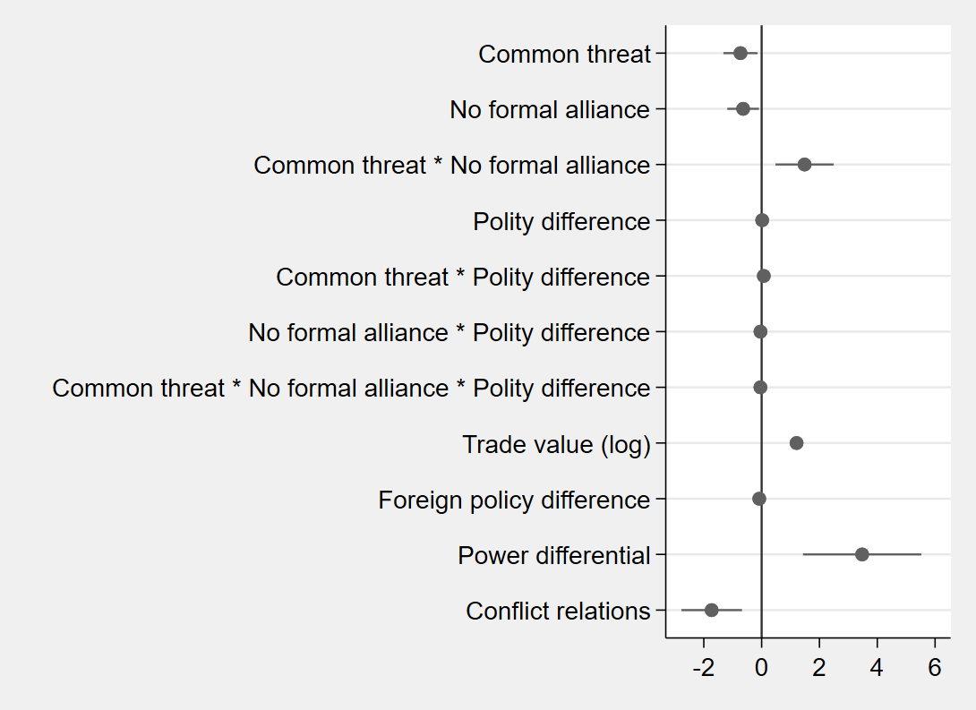
Note: Model 4. Logistic regression estimates with 95% confidence intervals. Dyad clustered standard errors. Variables whose intervals overlap with the vertical line are statistically indistinguishable from 0.

Figure 2. Marginal effect of common threat on BISP tie as polity difference increases by alliance
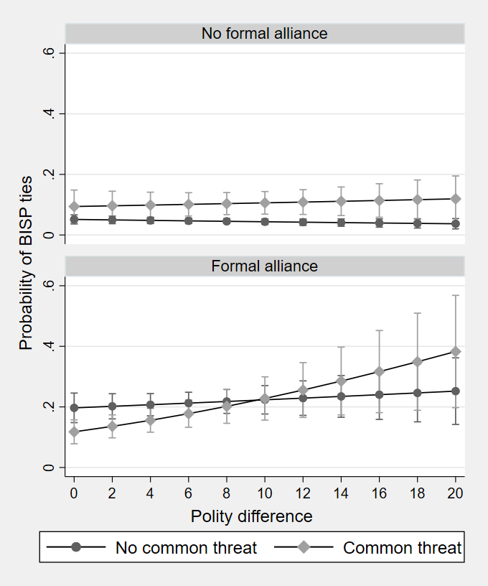

Figure 3. Results of the logistic regression
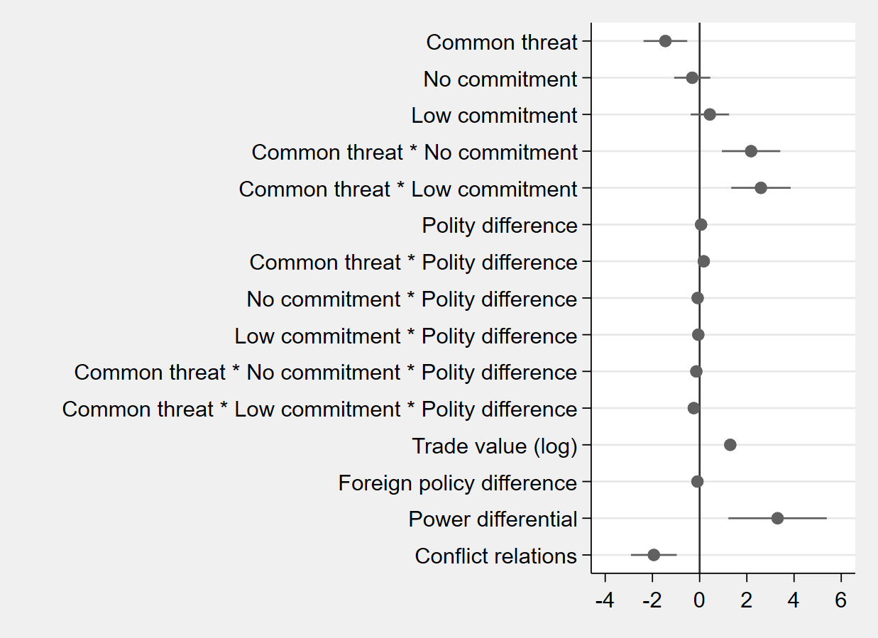
Note: Model 4. Logistic regression estimates with 95% confidence intervals. Dyad clustered standard errors. Variables whose intervals overlap with the vertical line are statistically indistinguishable from 0.

Figure 4. Marginal effect of common threat on BISP tie as polity difference increases by the type of alliance commitment
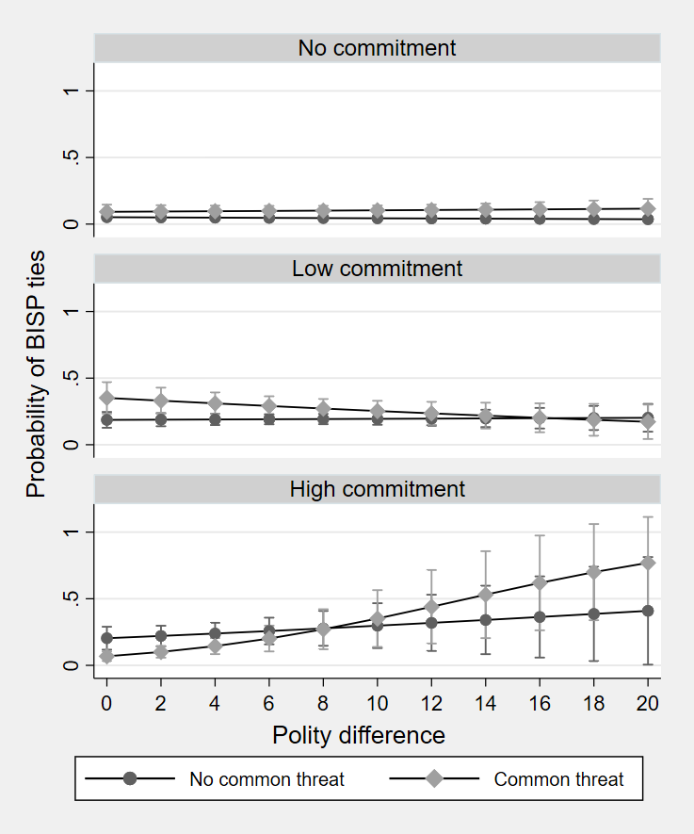

Appendix 8 – Alternative operationalization of polity difference
During the review process, one of the reviewers suggested to control for the regime type itself and not just Polity difference. Unfortunately, the undirected dyadic format limits the options for alternative measures of regime type as it requires eliminating any identity or directionality (e.g., source – target). Consequently, we cannot include individual-level variables, such as Polity_{i} and Polity_{j}. Regardless, to ensure that the results are robust, I tested two alternative operationalizations of Polity difference. Table 1 and 2 below show the results when using dummies for regime similarity/difference.
Table 1. Logistic regression of BISP ties
 | Model 11 | Model 12
Common threat | 0.157 | -0.376
 | (0.199) | (0.238)
No formal alliance | -0.494** | -0.870***
 | (0.186) | (0.198)
Common threat * No formal alliance |  | 1.424***
 |  | (0.349)
Trade value (log) | 1.195*** | 1.196***
 | (0.0972) | (0.0991)
Joint democracy | -0.414* | -0.342
 | (0.176) | (0.179)
Joint autocracy | -0.282 | -0.348
 | (0.490) | (0.515)
Mixed regime dyad | -0.250 | -0.257
 | (0.224) | (0.228)
Foreign policy difference | -0.00638 | -0.0414
 | (0.0780) | (0.0796)
Power differential | 3.955*** | 3.969***
 | (1.035) | (1.045)
Conflict relations | -1.581*** | -1.570***
 | (0.469) | (0.444)
Constant | -5.637*** | -5.412***
 | (0.390) | (0.391)
N | 2808 | 2808
McFadden Pseudo R² | 0.242 | 0.253
Note: Dyad clustered standard errors in parentheses; * p < 0.05, ** p < 0.01, *** p < 0.001

Table 2. Logistic regression of BISP ties
 | Model 13 | Model 14
Common threat | 0.423* | -1.223**
 | (0.208) | (0.406)
No commitment | 0.430 | -0.641*
 | (0.308) | (0.311)
Low commitment | 1.292*** | 0.256
 | (0.293) | (0.322)
Common threat * No commitment |  | 2.270***
 |  | (0.478)
Common threat * Low commitment |  | 1.927***
 |  | (0.491)
Trade value (log) | 1.249*** | 1.279***
 | (0.0984) | (0.103)
Joint democracy | -0.162 | -0.135
 | (0.185) | (0.186)
Joint autocracy | -0.184 | -0.332
 | (0.532) | (0.542)
Mixed regime dyad | -0.291 | -0.325
 | (0.233) | (0.239)
Foreign policy difference | -0.0466 | -0.0971
 | (0.0804) | (0.0817)
Power differential | 3.630*** | 3.401**
 | (1.072) | (1.093)
Conflict relations | -1.879*** | -2.004***
 | (0.515) | (0.524)
Constant | -6.783*** | -5.857***
 | (0.519) | (0.501)
N | 2808 | 2808
McFadden Pseudo R² | 0.259 | 0.275
Note: Dyad clustered standard errors in parentheses; * p < 0.05, ** p < 0.01, *** p < 0.001

Of the newly added measures of regime similarity/difference, only the Joint democracy dummy attained a statistically significant and negative association with the dependent variable in Model 11. It would, therefore, seem that pairs of democracies are less likely to have a BISP. However, models 12 through 14 fail to produce the same result, which suggests that the association could be spurious.

Because the results of the previous test were inconclusive, I additionally tested an alternative continuous measure of regime similarity/difference, drawing on the data from the V-Dem Project. I obtained the values of Electoral democracy index difference by calculating the absolute difference between the two states’ scores on the “v2x_polyarchy” item – this is an interval variable running from 0 to 1, capturing the extent to which the ideal of electoral democracy is achieved. Nevertheless, as shown in Table 3 and 4 below, the alternative variable fails to attain any statistical significance, indicating that regime type plays little to no role in the selection of partners for cooperation.
Table 3. Logistic regression of BISP ties
 | Model 15 | Model 16
Common threat | 0.0969 | -0.394
 | (0.192) | (0.228)
No formal alliance | -0.524** | -0.872***
 | (0.178) | (0.188)
Common threat * No formal alliance |  | 1.376***
 |  | (0.345)
Trade value (log) | 1.204*** | 1.207***
 | (0.0941) | (0.0959)
Electoral democracy index difference | 0.382 | 0.257
 | (0.322) | (0.327)
Foreign policy difference | -0.0285 | -0.0506
 | (0.0798) | (0.0806)
Power differential | 3.656*** | 3.566***
 | (0.966) | (0.978)
Conflict relations | -1.403** | -1.407***
 | (0.453) | (0.426)
Constant | -5.934*** | -5.675***
 | (0.364) | (0.369)
N | 2996 | 2996
McFadden Pseudo R² | 0.247 | 0.257
Note: Dyad clustered standard errors in parentheses; * p < 0.05, ** p < 0.01, *** p < 0.001

Table 4. Logistic regression of BISP ties
 | Model 17 | Model 18
Common threat | 0.404* | -1.241**
 | (0.203) | (0.405)
No commitment | 0.521 | -0.541
 | (0.309) | (0.309)
Low commitment | 1.422*** | 0.380
 | (0.293) | (0.317)
Common threat * No commitment |  | 2.230***
 |  | (0.479)
Common threat * Low commitment |  | 1.948***
 |  | (0.486)
Trade value (log) | 1.272*** | 1.301***
 | (0.0962) | (0.101)
Electoral democracy index difference | -0.189 | -0.261
 | (0.351) | (0.356)
Foreign policy difference | -0.0389 | -0.0818
 | (0.0842) | (0.0845)
Power differential | 3.135** | 2.784**
 | (0.982) | (1.022)
Conflict relations | -1.744*** | -1.858***
 | (0.495) | (0.505)
Constant | -6.983*** | -6.025***
 | (0.472) | (0.462)
N | 2996 | 2996
McFadden Pseudo R² | 0.268 | 0.283
Note: Dyad clustered standard errors in parentheses; * p < 0.05, ** p < 0.01, *** p < 0.001

Appendix 9 – Examples of BISPs as “stepping stones” for formal alliances
During the review process, one of the reviewers suggested that it would be important to address the theoretical possibility that BISPs may also serve as steppingstones towards the formation of formal alliances. Accordingly, I have surveyed the universe of cases of dyads with G20 countries as one of the members and looked for instances where states tied by a BISP established a formal alliance. In so-doing, I have filtered out all cases where states already had a formal alliance prior to the onset of a BISP or where the onset of a BISP coincided with the onset of a formal alliance. Following is a list of all cases that meet these criteria (see Table 1). Data on BISPs come from the dataset accompanying the manuscript, data on formal alliances come from the Alliance Treaty Obligations and Provisions dataset. These cases can be seen as instances where BISPs potentially served as steppingstones for the formation of formal alliances. Interestingly, the results suggest that BISPs rarely evolve into formal alliances – in fact, by the end of 2018, only 33 cases fulfilled the above criteria. When they do, however, they invariably evolve into “low commitment” alliances, namely pure non-aggression pacts, which merely oblige members not to take military action against each other. This finding is curious because even though these “low commitment” alliances still represent a step forward in terms of formalizing cooperation – unlike BISP, they are legally binding – they are not significantly different in terms of the depth of cooperation.

Table 1. A list of BISPs serving as “steppingstones” for the formation of formal alliances
Dyad | BISP onset | Alliance onset | Alliance type
USA-EGY | 2009 | 2016 | Pure non-aggression pact
USA-CHN | 1997 | 2009 | Pure non-aggression pact
USA-IND | 2001 | 2009 | Pure non-aggression pact
CAN-BRA | 2011 | 2012 | Pure non-aggression pact
CAN-CHL | 2013 | 2015 | Pure non-aggression pact
CAN-CHN | 2005 | 2010 | Pure non-aggression pact
BRA-UKG | 1997 | 2012 | Pure non-aggression pact
BRA-FRN | 2006 | 2012 | Pure non-aggression pact
BRA-RUS | 2002 | 2012 | Pure non-aggression pact
BRA-TUR | 2010 | 2012 | Pure non-aggression pact
BRA-CHN | 1993 | 2012 | Pure non-aggression pact
BRA-IND | 2006 | 2012 | Pure non-aggression pact
BRA-IDN | 2008 | 2012 | Pure non-aggression pact
UKG-EGY | 2015 | 2016 | Pure non-aggression pact
UKG-CHN | 2004 | 2012 | Pure non-aggression pact
UKG-IND | 2004 | 2012 | Pure non-aggression pact
UKG-PAK | 2011 | 2012 | Pure non-aggression pact
UKG-DRV | 2010 | 2012 | Pure non-aggression pact
FRN-CHN | 2004 | 2006 | Pure non-aggression pact
FRN-JPN | 1995 | 2006 | Pure non-aggression pact
FRN-IND | 1998 | 2006 | Pure non-aggression pact
RUS-MOR | 2002 | 2016 | Pure non-aggression pact
RUS-EGY | 2009 | 2016 | Pure non-aggression pact
CHN-CHL | 2012 | 2016 | Pure non-aggression pact
CHN-BLR | 2013 | 2015 | Pure non-aggression pact
CHN-EGY | 2014 | 2016 | Pure non-aggression pact
CHN-TKM | 2013 | 2014 | Pure non-aggression pact
JPN-CHL | 2007 | 2016 | Pure non-aggression pact
JPN-EGY | 2007 | 2016 | Pure non-aggression pact
JPN-IND | 2000 | 2003 | Pure non-aggression pact
IND-TAJ | 2012 | 2015 | Pure non-aggression pact
IND-UZB | 2011 | 2015 | Pure non-aggression pact
IND-KZK | 2009 | 2015 | Pure non-aggression pact
Note: The list is based on a pool of cases of dyads with the involvement of G20 countries as one of the members, 1993–2018.

References
Aronow, P. M., Samii, C., & Assenova, V. A. (2015). Cluster-robust variance estimation for dyadic data. Political Analysis, 23(4), pp. 564–577. https://doi.org/10.1093/pan/mpv018
Brambor, T., Clark, W. R., & Golder, M. (2006). Understanding interaction models: Improving empirical analyses. Political Analysis, 14(1), pp. 63–82. https://www.jstor.org/stable/25791835
Carlson, J., Incerti, T., & Aronow, P. M. (2021). Dyadic clustering in International Relations. Unpublished manuscript. https://arxiv.org/pdf/2109.03774.pdf
Erikson, R. S., Pinto, P. M., & Rader, K. T. (2017). Dyadic analysis in International Relations: A cautionary tale. Political Analysis, 22(4), pp. 457–463. https://doi.org/10.1093/pan/mpt051
Leeds, B. A. (1999). Domestic political institutions, credible commitments, and international cooperation. American Journal of Political Science, 43(4), pp. 979–1002. https://doi.org/10.2307/2991814
Neumayer, E., & Plümper, T. (2010). Spatial effects in dyadic data. International Organization, 64(1), pp. 145–166. https://doi.org/10.1017/S0020818309990191
Strüver, G. (2017). China’s partnership diplomacy: International alignment based on interests or ideology. The Chinese Journal of International Politics, 10(1), 31–65. https://doi.org/10.1093/cjip/pow015
Vabulas, F., & Snidal, D. (2013). Organization without delegation: Informal intergovernmental organizations (IIGOs) and the spectrum of intergovernmental arrangements. Review of International Organizations, 8(2), pp. 193–220. https://doi.org/10.1007/s11558-012-9161-x

The package is available at https://github.com/jscarlson/stata-dcr
I followed Leeds (1999) and coded Joint democracy as “1” if both states had a Polity V score above 5, Joint autocracy as “1” if both states had a Polity V score below -5, and Mixed-regime dyad as “1” if one state was a democracy (Polity V above 5) and the other an autocracy (Polity V below -5).
See https://v-dem.net/
This assumption is based on the argument advanced by some contributions to the literature on informal institutions. For instance, Vabulas and Snidal (2013, pp. 212–213) argue that informal intergovernmental organizations can act as building blocks to more institutionalized forms of cooperation because they allow states to learn the advantages of increasing the institutionalization of an issue. Some contributions to the empirical literature on strategic partnerships also acknowledge this possibility. For instance, Strüver (2017, p. 38) notes that strategic partnerships have the potential to foster and deepen interstate trust, which can induce further institutionalization in the future.
See http://www.atopdata.org/

